**Kirtiraj Lekhraj Singh**

**Permanent Address:-**B.M.C.H 905/1E Katrak Road, Wadala, Mumbai -4000031, INDIA. **Current Address:-**R K Apartment,108 Room,2nd Floor, B-Wing, Near Wadala Bus Depot, Sewri Cross Street, Wadala, Mumbai-400031, INDIA.

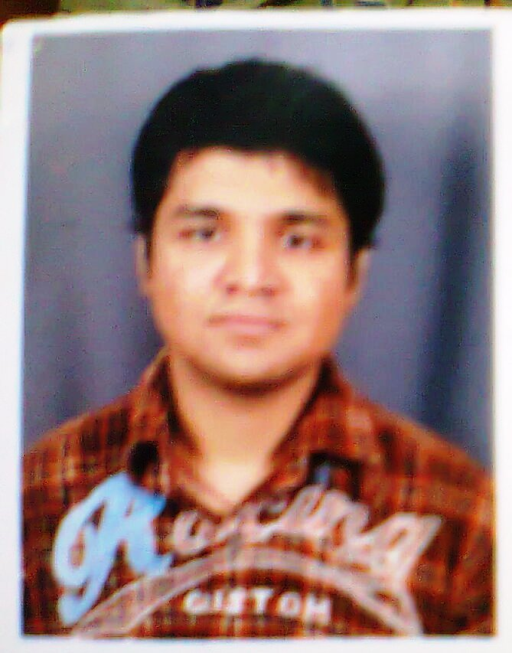

**singh.kirtiraj@gmail.com +91 09969963596**

**singh.kirtiraj@rediffmail.com +91 022 24104515**

**Core Competencies (Objectives): -**  
Aiming to be associated with a progressive organization that gives me

support to update my knowledge, skills in accordance with the latest trends and be part of a team that dynamically works towards growth of organization.

**Work Experience**

**Appointed to the position of “AR(Account Receivable)”**

**GEBBS** – New Mumbai, Maharashtra

June 2016 to January 2017

Responsibilities  
Work for Six Month.  
Working Account Receivable

Process From Billing Virtual Radiology ILLINOI, CALAFORNIA & TAXES. Which is part

Work For Doctors (Providers) To Solves The Claims of Patients Behave of Doctors(Providers) To Talks Insurance Representatives on Information Available or Helps on Websites Available to us for Billing Purposes to Insurances. Imagine Software which is GEBBS’s Software’s Online Server of the Global Billing Companies. Its Third Parties Between Clearance Houses And Insurances. In Short way its call “ Medical Billing” I Insurances Like Hospice(For Dying Peoples) Insurances, Medicare (Above 65) Insurances And Medicaid (Poor Peoples) Insurances, Insurances Veterans(For Service Member) Insurances, Champ US Insurances,(For Officers) Champ VA Insurances (For Officers), Tri care, Insurances(For Officers).BCBS,UHC and Other Insurances All Worlds Overseas.

Accomplishments

Experiencing of New Learning And Trained as RCM And Denials HIFA (CMS1500),UB-04 Form EOB (Result of Payment or Not By Insurance Electronic Paper ),Claim Number (ICN),Policy ID (Subscriber ID, Patient ID),CPT, DOS, All Kinds of Amounts Etc.

When Join this Process Started New Held for Six Month. More Than 5000$ Earn in Last End Three Months and Going on Since Process Extend for Two Month More. My Strength Is 116% in Quality as Good. As My Background is Different With Hard Work As Team It is Possible to Do That Much Business. I Just Do as Per Business Need In Team.  
  
Skills Used  
for Billing. Learn All Kind Of Medical Billing Knowledge

**Appointed to the position of “ROTO Artist”**

**1Point1** – New Mumbai, Maharashtra

March 2016 to May 2016

May 2016 to June 2016

Responsibilities  
Work for Three Month.  
Working Roto Artist

Work as Training on International Project for Shorts Plates Outline Movies likes Monster Trucks.2017,Teenage Mutant Ninja Turtles Movie (2014) The Man from U.N.C.L.E (2015) Etc. Sits A Node Base Software Set Plates Resolution, Frames & Ratio Format Before Created New Project in View Port, Time Line, Key Frame, Polygons (Masking or Cutting Things from Scene)Node, Merge(Connecting) Node, SV (Final Movie After Editing )Node, BC (Background use as Color to Your Mask Area use further Cut and Past in Other Scene ) Node And Rendering Format. Every Nodes Properties , Filters Etc.

Accomplishments  
Experiencing of New Training Learning A Plate Contains En-Numbers Scenes (Frames) Masking Format

Skills Used  
Fusion Software Learn New Software’s Silhouette & PF Track.

**Photoshop based appointed to the position of “Digital Merchandiser Executive”**

**Accenture** - Mumbai, Maharashtra

October 2014 to February 2015

Responsibilities  
Currently worked for 3 month Contract which is Ended on 27th Feb 2015.  
SMT(Stitching Management Tool)and EMT(Exceptional Management Tool) which are Accenture’s Software’s Online Server of the Global Companies. QC (Quality Checking) Also I do. And DMS (Digital Merchandiser System) Software’s Online Server of the Global Companies, I was Learning.  
Photoshop based appointed to the position of “Digital Merchandiser Executive” in ACDM Department.Through “ Resource Square Solution Pvt. Ltd “Consultancy.  
  
Accomplishments  
Experiencing of New Learning  
  
Skills Used  
Kind OF PhotoShop Software Used in SMT And EMT Software

**3D Modeler (Animation)**

**Maya digital Studio** - Mumbai, Maharashtra

March 2014 to June 2014

Responsibilities  
Training as 3D Modeler, Texturing for three months. Completed at the end of June 2014.  
Work in ‘ON AIR’ Production Project ’ Motu Patlu ’ ON Nickelodeon TVs India And ‘V.I.R The Robot Boy’ Come ON Hungama TVs India  
  
Accomplishments  
Experiencing of New Learning in Internship  
  
Skills Used  
3-D Modeling and Texturing

**3D Modeler (Animation)**

**Tech sys Media Pvt. Ltd** - Mumbai, Maharashtra

October 2013 to February 2014

Responsibilities  
Work for Three Month.  
Working as a Modeling, Texturing, Animation and Lighting Artist & Compositor Artist and Knowledge of Graphic Design a Bit.

Project Work Summary:-  
Globe Project:-Model 3D Earth, Jumping line from one place to another place and pop pin (A point pop out to show where it is) and do Animation, Texturing and Rendering in 3DS Maya Software Using Mental Ray Engine renderer for German Company.  
Castrol Project:-Completed Model: Car Simulator, Some Machine Motors and Modified given Model: Bike Simulator, Some Machine Motors in Castrol Company Project. Some are textured and Lighting done by me. And also working on baking all for Game and many more. I have also do Graphic work like Android Lumina BG and some more that works in Webs and Phones Using Photoshop, Illustrator and Bit of Flash Software  
For Small Production Company & working on Animal Health Care Company Using After-Effect Software  
  
Accomplishments  
Experiencing of new Learning   
  
Skills Used  
3-D Modeling and Texturing

**Education**

**B.A (Under Graduation) in Animation (VFX)**

**First Year** in B.A in Animation (VFX) – **Certification in Digital Film Making**

**Second Year** in B.A in Animation (VFX) – **Diploma in Computer Generated Imagery**

**Third Year** in B.A in Animation (VFX) – **Bachelor of Arts in 3D Animation**

**Maya Academy of Advanced Cinematic Institute :-****Affiliated -** Dadar, Mumbai, Maharashtra

**IGNOU University** – New Delhi

June 2013

**Professional Diploma in Animation Design- Specialization in V/FX & Compositing**

**Meteor Institute of Digital Design Studies Pvt. Ltd. (MIDDS) Institute –**Andheri, Mumbai, Maharashtra

June 2010

**Maharashtra State in Certification Information Technology(MSC-IT)**

**Maharashtra State Board Of Technical Education** – Nariman Point, Mumbai, Maharashtra

July 2005

**HSC (12th) in Computer Science**

**Mumbai Junior College Of Arts, Science & Commerce** – Wadala, Mumbai, Maharashtra

**Maharashtra State Board Of Secondary and Higher Secondary Education** - Pune, Maharashtra

Feb 2010

**FYJC (11th) in Biology**

**Mumbai Junior College Of Arts, Science & Commerce** - Wadala, Mumbai, Maharashtra

April 2006

**School (10th)SSC**

**Shri Bansidhar Aggarwal Model School & Junior College -** Wadala, Mumbai, Maharashtra

**Maharashtra State Board Of Secondary and Higher Secondary Education**- Pune, Maharashtra

March 2005

# Technical Skills in Software’s:-

Autodesk 3DS Max

Autodesk 3DS Maya

Autodesk Mud-Box

Adobe Photoshop

Adobe Premiere Pro

Adobe After Effect

Eye on Digital Fusion

**Online Links of Project work**

http://www.youtube.com/watch?v=3O4oM9DIqo4

http://www.youtube.com/watch?v=RTQB9MjCUro

**Face Book Photo**

https://www.facebook.com/Kirtiraj.Lekhraj.Singh

**Additional Information**

Personal Dossier (Other Details):-  
Sex : Male  
Date of Birth : 09 November 1987  
Place: Mumbai  
Languages Known: English, Hindi and Marathi.  
Nationality: Indian  
Passport No: J908169;Validity-27th June,2021  
Marital Status: Single  
Hobbies: Singing, Internet-Surfing, Reading, Music, All Games, Cartoon Sound Dubbing .Sky, Water-Diving & Surfing   
.**Declaration:** I hereby declare that the above information furnished is true to the best of my knowledge

. **(Kirtiraj Lekhraj Singh)**